**ĐẠI HỌC BÁCH KHOA HÀ NỘI**

**Trường Điện – Điện Tử**



**Smart Agricuture Systems**

|  |  |
| --- | --- |
| Design authors: | Trần Bá Thản  Bùi Đức Hiếu  Phạm Thanh Phong  Nguyễn Minh Tiến  Vũ Đình Phúc Minh |

***Hanoi, September/2023***

**Table of Contents**

**LIST OF FIGURES** 4

**LIST OF TABLES** 5

**INTRODUCTION** 6

**CHAPTER 1: OVERVIEW OF THE SYSTEM** 7

**1. Overview** 7

**2. Selected devices** 9

**2.1. Micro Processors** 9

**2.2. Sensors** 10

**2.3. Execution Components** 11

**2.4. Cloud** 12

**2.5. User Interface** 12

**CHAPTER 2: SYSTEM STRUCTURE AND ALGORITHMS** 14

**2.1. System Diagram and Operating Principles** 14

**2.1.1 Nodes** 15

**2.1.2. Station** 18

**2.1.3. Server** 20

**2.1.4. Application** 22

**2.2. Algorithms** 23

**2.2.1 Nodes** 23

**2.2.2 Station** 27

**CHAPTER 3: HARDWARE AND SOFTWARE DESIGN** 29

**3.1. Hardware Design** 29

**3.1.1 Supply circuit** 29

**3.1.2. Isolation circuit** 29

**3.1.3. Sensors** 29

**3.1.4. Pumps** 30

**3.1.5. Fan** 31

**3.1.6 LoRa** 31

**3.1.7 KiT EK2703A** 31

**3.2. Software Design** 32

**3.2.1 Start interface (on Station)** 32

**3.2.2 App (on Mobile)** 33

**CHAPTER 4: RESULTS AND PRODUCT EVALUATION** 36

**4.1. Design results** 36

**4.2. Test Results** 37

**4.3. Future Development Directions** 37

**CONCLUSION** 38

# **LIST OF FIGURES**

Figure 1: Hi-Tech agricultural systems 7

Figure 2: Central node netwwork 8

Figure 3: Cloud Tech 8

Figure 4: Micro processor 9

Figure 5: Sensors 10

Figure 6: Cloud 12

Figure 7: System diagram 14

Figure 8: System for full garden 14

Figure 9: Node motor 15

Figure 10: Inside node sensor 17

Figure 11: Station monitor 18

Figure 12: Tables of database 20

Figure 13: Firebase Cloud Messaging 21

Figure 14: How hashing algorithms works 21

Figure 15: Node sensor algorithms 23

Figure 16: Letimer interrupt 24

Figure 17: EUSART interrupt 25

Figure 18: Main node motor algorithms 27

Figure 19: Thread 1 algorithms 27

[Figure 20: Thread 2 algorithms 28](https://husteduvn-my.sharepoint.com/personal/than_tb202769_sis_hust_edu_vn/Documents/DD.docx#_Toc146129686)

[Figure 21: Soil moisture sensor 29](https://husteduvn-my.sharepoint.com/personal/than_tb202769_sis_hust_edu_vn/Documents/DD.docx#_Toc146129687)

[Figure 22: Air humidity sensor & Temperature sensor 30](https://husteduvn-my.sharepoint.com/personal/than_tb202769_sis_hust_edu_vn/Documents/DD.docx#_Toc146129688)

[Figure 23: Irrigation Header 30](https://husteduvn-my.sharepoint.com/personal/than_tb202769_sis_hust_edu_vn/Documents/DD.docx#_Toc146129689)

[Figure 24: Water Pump 30](https://husteduvn-my.sharepoint.com/personal/than_tb202769_sis_hust_edu_vn/Documents/DD.docx#_Toc146129690)

[Figure 25: Fan 31](https://husteduvn-my.sharepoint.com/personal/than_tb202769_sis_hust_edu_vn/Documents/DD.docx#_Toc146129691)

[Figure 26: Module RF SX1278 Lora E32 31](https://husteduvn-my.sharepoint.com/personal/than_tb202769_sis_hust_edu_vn/Documents/DD.docx#_Toc146129692)

Figure 27: Log in intergace on station 32

Figure 28: Log in interface 33

Figure 29: Sign in interface 33

Figure 30: Dashboard 34

Figure 31: Setting interface 34

Figure 32: Notifications interface 35

Figure 33: Pairing device on App 35

Figure 34: Station 36

Figure 35: Node sensors 36

Figure 36: Node motors 37

# **LIST OF TABLES**

Table 1: Node Motor Structure 16

Table 2: List of performent components on Node motor 16

Table 3: Node Sensor Structure 17

Table 4: Station Components 18

Table 5: Connection mode for specific garden 19

Table 6: Control mode for specific garden 20

Table 7: Range of warning setting 22

# **INTRODUCTION**

The dawn of agriculture was a momentous turning point in human history, signifying our ability to manipulate the environment to produce sustenance for a burgeoning population. For more than 12,000 years, agriculture has been the cornerstone of human progress, leading to significant milestones such as the cultivation of diverse crops, harnessing the power of fire, and the evolution of culinary practices. This journey has propelled us into an era where self-driving machinery and cutting-edge smart agricultural systems define the agricultural landscape.

However, as we stand on the threshold of the 21st century, we confront a new juncture in the history of agriculture. Projections suggest that the global population will reach a staggering 9.7 billion people by 2050. This demographic surge has placed immense pressure on the agricultural industry to not only increase production but also adapt to evolving nutritional preferences. The ramifications are profound, with these demands exerting an unprecedented strain on the ecological health of our planet.

In response to these formidable challenges, the concept of "smart agriculture systems" has emerged as a beacon of hope. These systems harness the transformative potential of automation and advanced technology to augment and optimize farming operations, thereby increasing efficiency and sustainability. Pioneering agriculture technology companies are leading the charge, birthing innovations such as drone-assisted operations, autonomous tractors, robotic harvesters, and automated seeding and irrigation systems.

In this article, our focus is to delve into a specific automated farming system that our team has designed, rather than providing a broad overview of various types of automated agriculture. We will explore the intricacies of this particular system, shedding light on its multifaceted advantages and inherent challenges. Additionally, we will highlight the obstacles that farmers face when adopting such cutting-edge technologies, including the initial cost barriers and the complexities involved in integrating specialized equipment into traditional farming practices. This article serves as an in-depth examination of our unique agricultural innovation and its potential implications.

As we navigate this profound transformation in agriculture, it is incumbent upon us to grasp the profound ways in which automated farming can chart a course towards a sustainable and flourishing future for humanity an d the delicate ecosystem of our planet.

# **CHAPTER 1: OVERVIEW OF THE SYSTEM**

## **1. Overview**

The large-scale agriculture leadership project is dedicated to advancing agricultural product development, particularly in the context of expansive agricultural operations. At its core, the project seeks to address the challenges faced by farmers by leveraging a sophisticated system.

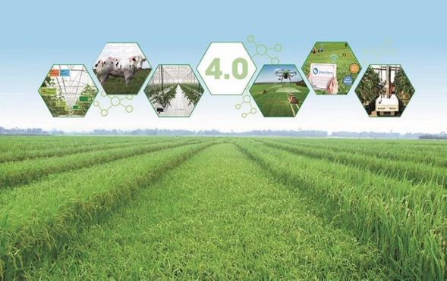

Figure : Hi-Tech agricultural systems

This comprehensive system incorporates a network structure featuring a central processing station and a network of distributed nodes. The central processing station serves as the nerve center, collecting and analyzing data from the various nodes. This data encompasses a wide range of critical agricultural factors, including weather conditions, soil quality, crop health, and resource allocation.

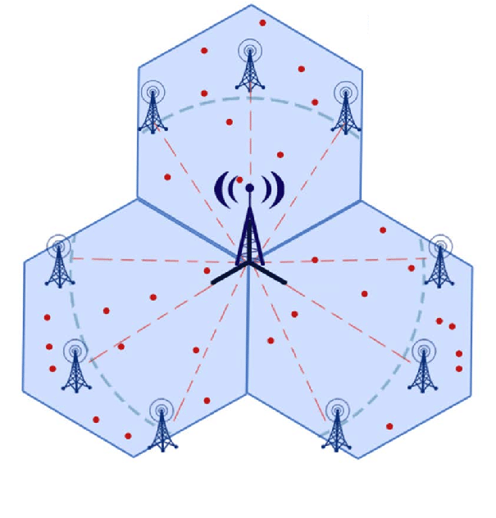

Figure : Central node netwwork

Complementing this network is a robust and extensive database infrastructure. This database acts as a repository for the vast amount of agricultural data, ensuring its accessibility and facilitating real-time monitoring and analysis. This, in turn, empowers farmers with the knowledge needed to make informed decisions in their farming practices.



Figure : Cloud Tech

To bridge the gap between technology and end-users, the project also includes a user-friendly mobile application. This application is tailored to the needs of agricultural practitioners, providing them with easy access to essential data and enabling them to track and manage their farming operations effectively.

In summary, this pioneering project represents a fusion of cutting-edge technology and agriculture, promising to revolutionize the sector. It not only enhances agricultural productivity but also eases the burden on farmers, ultimately contributing to global food security. With its network structure, extensive database, and user-centric application, this initiative represents a significant step forward in the world of agriculture, ensuring a more sustainable, efficient, and farmer-friendly future.

## **2. Selected devices**

### **2.1. Micro Processors**

In this system, a critical requirement is the efficient use of energy, given that the nodes are deployed outdoors and spaced at a considerable distance from each other, making battery replacement a challenging task. Therefore, the selection of processing units plays a pivotal role in achieving energy savings and ensuring the system's longevity.



Figure : Micro processor

The chosen processing units must possess several key characteristics to meet these stringent energy-saving demands:

- Low Power Consumption: The selected microprocessors should have a significantly low power consumption profile to ensure that they can operate on limited energy resources for extended periods. This is crucial for nodes powered by batteries or solar panels, as it extends the time between recharges or replacements.

- Low-Power Sleep Mode: The processors should be capable of entering deep sleep modes with extremely low power consumption when not actively processing data. This feature is essential to conserve energy during idle periods, allowing nodes to operate efficiently even when they are not actively engaged in data collection or transmission.

- High Precision and Accuracy: Despite their energy-saving capabilities, these microprocessors should maintain high levels of accuracy and precision in data processing and analysis. This ensures that the information collected and transmitted by the nodes remains reliable and trustworthy for decision-making.

- Energy Harvesting Compatibility: If applicable, the chosen processors should be compatible with energy harvesting technologies, such as solar panels or wind turbines, to supplement and recharge their energy reserves from renewable sources.

- Robust Communication: Efficient data communication protocols should be implemented to minimize energy expenditure during data transmission between nodes and the central processing station. This ensures that energy is not wasted during data transfer.

- Longevity and Durability: The processors should be selected for their durability and longevity in harsh outdoor environments, reducing the need for frequent replacements.

By carefully considering these criteria and selecting microprocessors that meet these stringent energy-saving requirements, the system can effectively optimize energy usage, extend the operational lifespan of the nodes, and contribute to the overall success of the agricultural leadership project. Also, this is the prerequisite factors to consider kind of the component in the future.

### **2.2. Sensors**

Within the network of nodes deployed throughout the agricultural landscape, an integral component of their functionality lies in their ability to gather crucial environmental data. These nodes are equipped with an array of sensors designed to measure various vital parameters, including temperature, humidity, both in the air and within the soil.

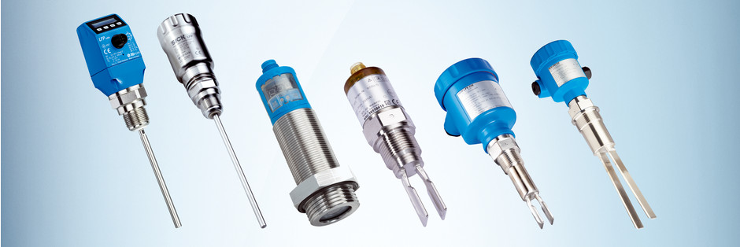

Figure : Sensors

- Temperature Sensing: Temperature plays a pivotal role in agricultural operations, influencing crop growth, pest control, and irrigation strategies. The nodes are outfitted with precision temperature sensors capable of accurately monitoring the ambient air temperature as well as the temperature of the soil in which crops are cultivated. This data provides farmers with real-time insights into temperature fluctuations, helping them make informed decisions regarding crop selection, planting times, and climate management.

- Humidity Sensing: Humidity levels in both the air and the soil are critical factors influencing crop health and growth. The nodes incorporate humidity sensors to measure the moisture content in the surrounding atmosphere and the soil. This data is invaluable in optimizing irrigation schedules and preventing overwatering or drought stress, ensuring optimal growing conditions for crops.

- Soil Moisture Sensing: Monitoring soil moisture content is a key aspect of precision agriculture. The nodes' soil moisture sensors delve beneath the surface to assess the water content within the soil. This information allows farmers to tailor their irrigation practices, preventing water wastage and optimizing crop hydration. Additionally, it aids in the prevention of soil erosion and nutrient leaching.

By harnessing these advanced sensors within the nodes, the agricultural leadership project empowers farmers with a wealth of real-time environmental data. This data, ranging from temperature and humidity to soil moisture levels, equips them with the insights needed to make informed decisions, enhance crop yields, and promote sustainable agricultural practices. It not only optimizes resource utilization but also contributes to the overall success and sustainability of modern farming techniques.

### **2.3. Execution Components**

Execution components include two irrigation motors responsible for controlling water distribution and a heating lamp designed to modulate temperature.

- Primary Irrigation Motor: The primary irrigation motor plays a central role in the agricultural node's functionality. It is responsible for regulating and distributing water to the soil, enhancing soil moisture levels to meet the specific requirements of the crops. The precise control over irrigation helps prevent water wastage, minimizes over-saturation, and ensures that plants receive the appropriate amount of moisture for optimal growth.

- Secondary Irrigation Motor: The secondary irrigation motor is equipped with a nozzle system capable of spraying water into the air. This function serves a dual purpose. Firstly, it increases the humidity in the surrounding atmosphere, creating a microclimate conducive to certain crops. Secondly, it can be utilized for the targeted application of nutrients such as potassium (K), nitrogen (N), and other essential elements. This controlled nutrient delivery contributes to improved crop nutrition and growth.

- Heating Lamp: The heating lamp is employed to modulate temperature conditions in the immediate vicinity of the agricultural node. By emitting heat, it can raise the temperature in the immediate area, preventing frost damage during cold nights or providing additional warmth during colder seasons. The heating lamp's temperature control capabilities are crucial for safeguarding crops from adverse weather conditions and maintaining an optimal growing environment.

These actuating components are meticulously integrated into the agricultural nodes to facilitate precise and responsive environmental control. Together with sensors that monitor temperature, humidity, and soil moisture levels, these components enable farmers to create customized microenvironments for their crops. By regulating irrigation, humidity, and temperature, farmers can optimize crop growth, mitigate environmental risks, and enhance the overall efficiency and sustainability of their agricultural operations.

### **2.4. Cloud**

In the context of your agricultural system, the server or cloud infrastructure plays a pivotal role as both a storage repository and a critical intermediary component connecting the hardware and software components of the system.



Figure : Cloud

- Storage Repository: The server or cloud serves as a centralized storage repository where all the data collected from the network of agricultural nodes is aggregated and stored securely. This repository ensures data integrity, accessibility, and long-term preservation, allowing for historical analysis and decision-making.

- Data Processing and Analysis: The server or cloud also serves as the computing powerhouse for data processing and analysis. It receives raw data from the nodes, processes it to extract meaningful insights, and conducts data analysis to derive actionable information. This analytical capability is crucial for making informed decisions about crop management, resource allocation, and optimization strategies.

- Connectivity and Communication Hub: As an intermediary component, the server or cloud acts as a central hub for communication between the hardware and software elements of the system. It facilitates real-time data exchange between the nodes and the software applications running on it, ensuring seamless integration and responsiveness.

The server or cloud infrastructure serves as the backbone of your advanced agricultural system, providing data storage and connectivity.

### **2.5. User Interface**

The user interface component of your agricultural system plays a crucial role in providing farmers and users with a user-friendly platform to interact with the system, access real-time data.

- User Account Creation: Users can create their accounts, providing essential information and security credentials. This allows for personalized access to the system and data.

- Dashboard: The user interface features a dashboard that provides an overview of the current status of the farm. Users can access historical data, enabling them to review past trends and make informed decisions

- System Configuration: Users have the ability to adjust system settings and configurations. This includes setting temperature and humidity thresholds, customizing irrigation schedules, and configuring the operation of actuating components like irrigation motors and heating lamps.

- Device Control: The interface allows users to remotely control devices and actuators within the agricultural nodes. Users can turn on or off irrigation systems, adjust the intensity of the heating lamp, or activate other components based on real-time needs and system analysis.

- Notifications and Alerts: The user interface can receive and display notifications and alerts from the server or cloud infrastructure.

- Security: Robust security measures, including user authentication and encryption, are implemented to protect user data and system integrity.

# **CHAPTER 2: SYSTEM STRUCTURE AND ALGORITHMS**

## **2.1. System Diagram and Operating Principles**

Our system utilizes a central node network as the primary hardware communication infrastructure. The central station functions as the core hub, where it processes incoming data from node sensors and manages the control of sensor motors.

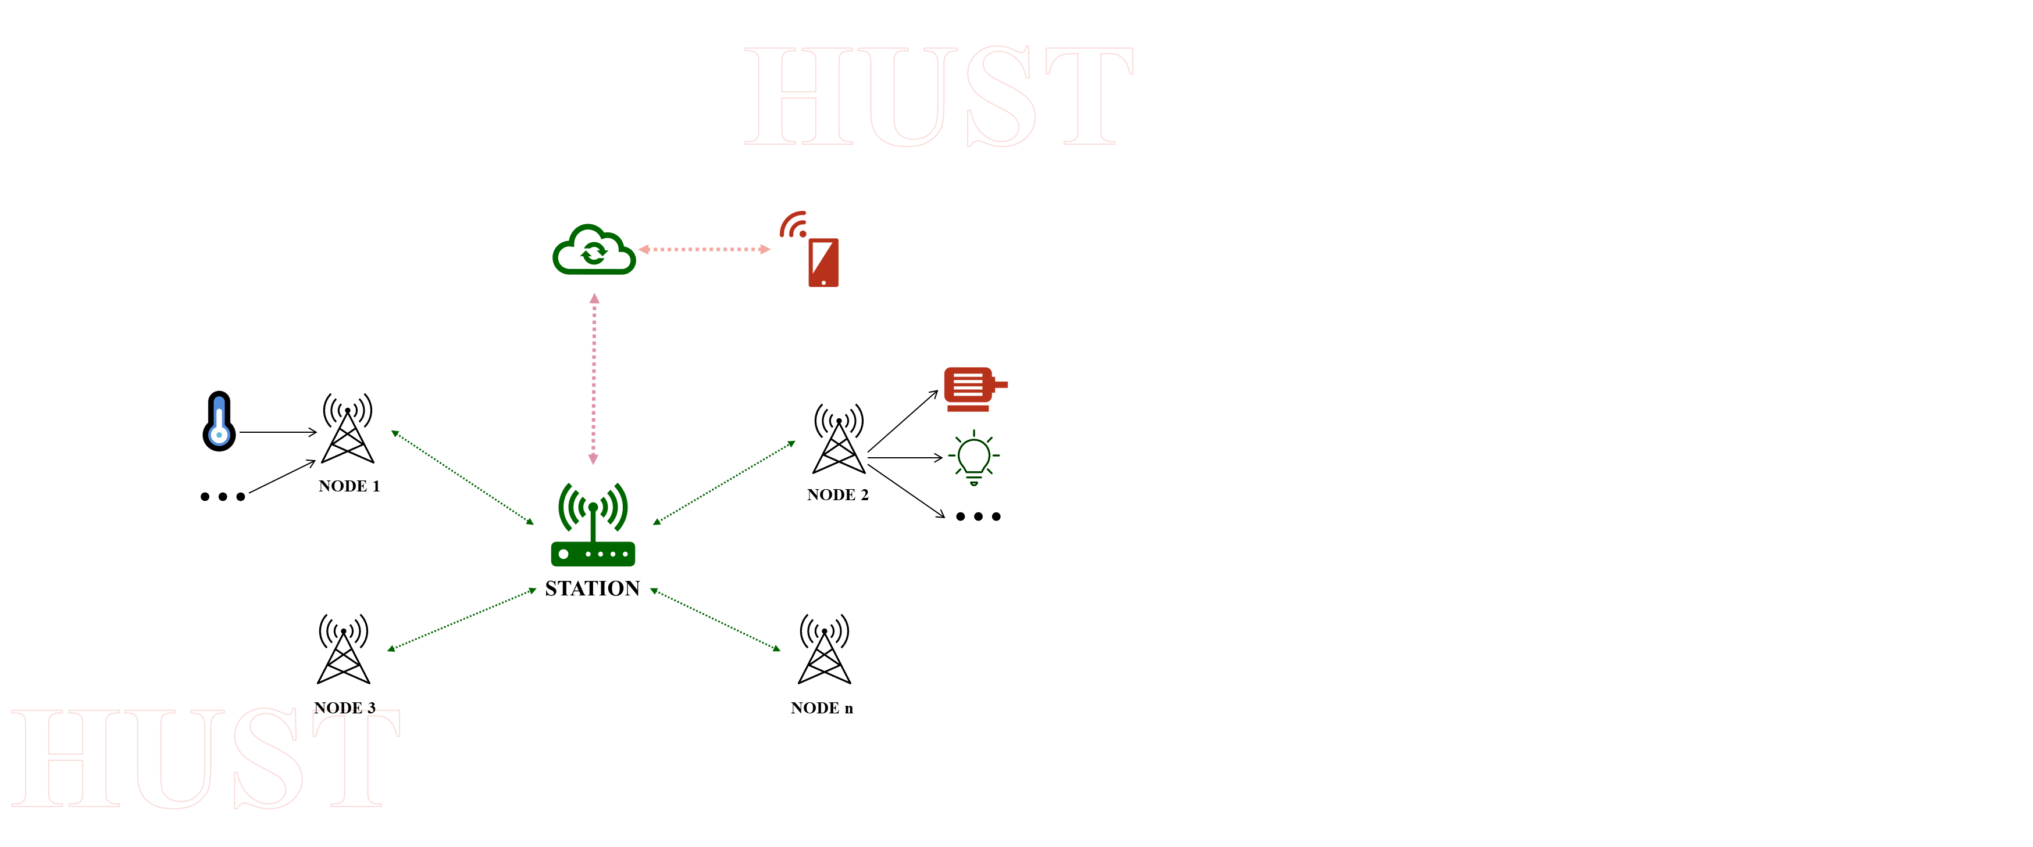

Figure 7: System diagram

Within this network, two types of nodes exist: node sensors, responsible for collecting environmental parameters and transmitting them to the central station, and node motors, which receive control commands from the central station and execute these commands.

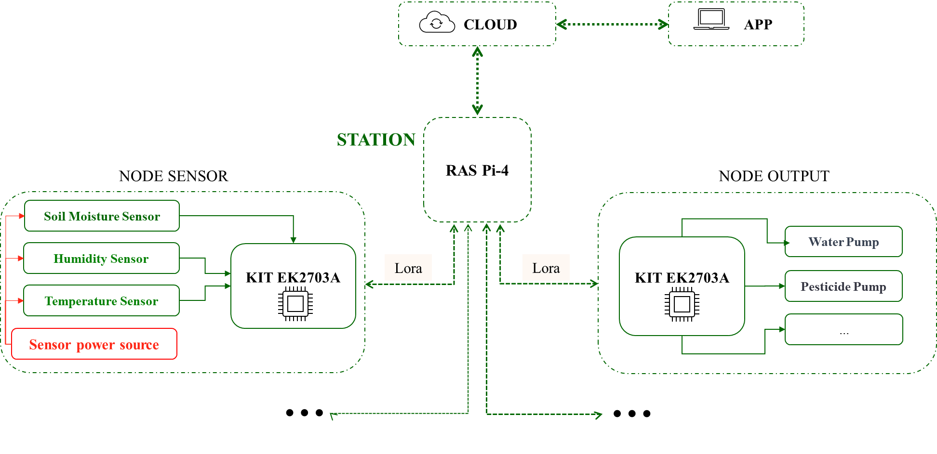

Figure 8: System for full garden

### **2.1.1 Nodes**

The system comprises two essential node types: motor nodes and sensor nodes. To initiate their functionality, these nodes must establish connections with the central processing station. During this setup, they exchange vital information, including channel addresses, LoRa bandwidths, and their specific node types.

#### **a. Motor Nodes**

Motor Nodes take on the critical role of executing physical actions on the farm, such as irrigation and temperature regulation. They communicate with the station to receive commands and status updates, ensuring precise control over irrigation systems and heating lamps.

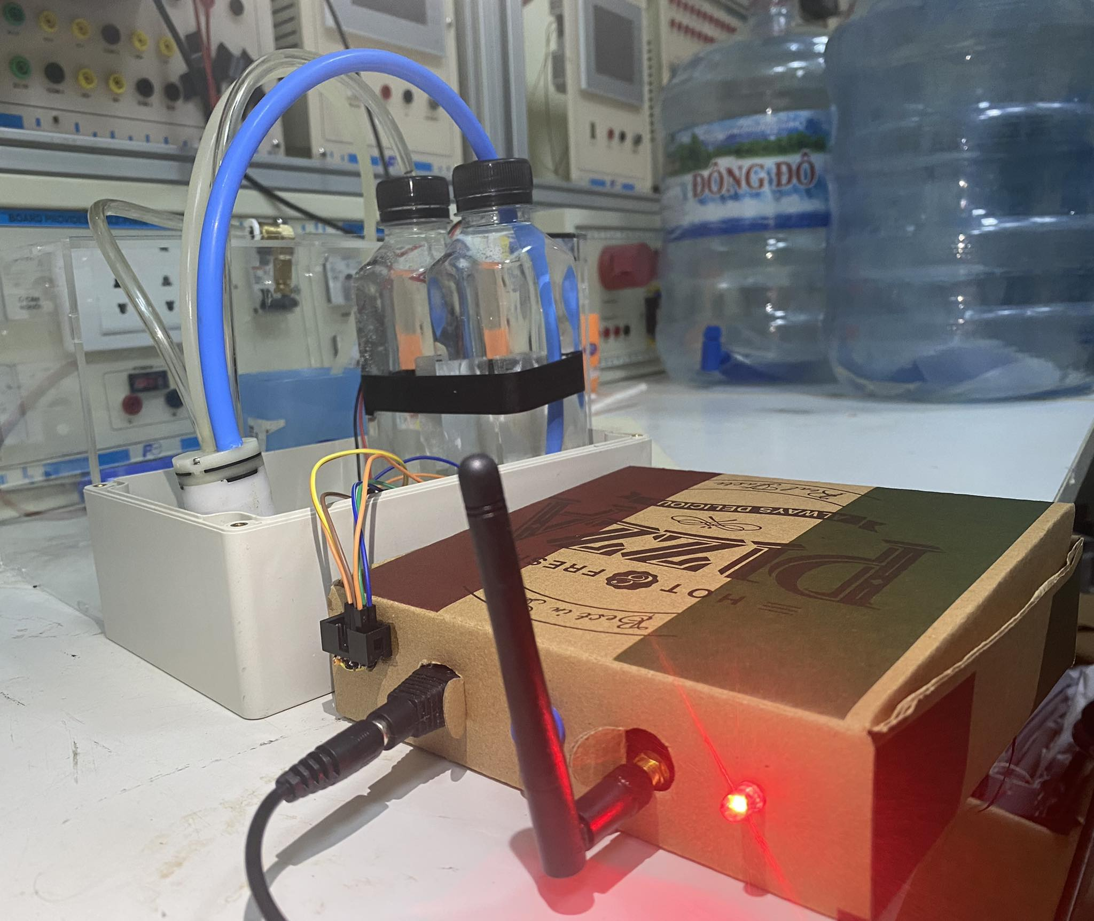

Figure 9: Node motor

* Structure:

Table 1: Node Motor Structure

|  |  |
| --- | --- |
| Main board | KiT: EK2703A |
| Pump | * Water Pump *MB370 DC3.7-6V* * Fan 5v |
| Power source | Adapter 5v |
| Network | Module Lora |
| Indicator | LEDs |

The operation of the motor nodes within the system can be outlined as follows:

- Receiving and Analyzing Control Data: Motor nodes are constantly in a standby mode, awaiting control data sent from the central processing station. Upon receiving this data, they analyze it to determine the appropriate action required. The control data typically includes instructions for turning the motors on or off.

- Component Activation: Based on the analysis of the control data, the motor nodes activate or deactivate the relevant motors.

Table 2: List of performent components on Node motor

|  |  |
| --- | --- |
| Pump 1 | Pump with mist nozzle |
| Pump 2 | Pump without mist nozzle |
| AC | Adjust temperature |

- Feedback to the Station: After executing the command, the motor node sends feedback to the central station, confirming that the requested action has been carried out correctly. This feedback mechanism ensures that the station receives confirmation of motor status changes.

- Checking data byte: Uses an rlc byte to check the correctness of the data to avoid loss, missing, or incomplete data.

#### **b. Sensor Nodes**

Sensor Nodes collect environmental data, including temperature, humidity, and soil moisture. They exchange information with the station to transmit real-time data for analysis, enabling informed decision-making in agriculture.

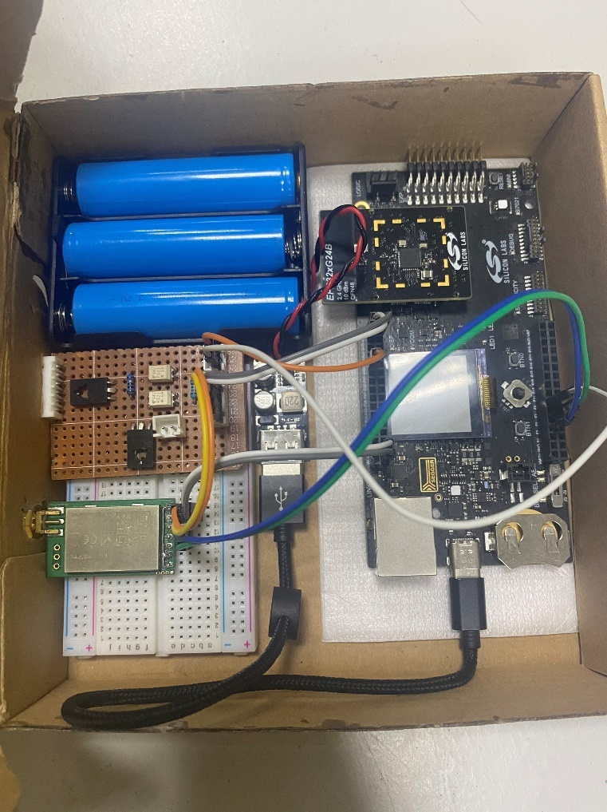

Figure 10: Inside node sensor

* Structure

Table 3: Node Sensor Structure

|  |  |
| --- | --- |
| Main board | KiT: EK2703A |
| Sensors | * Soil Moisture Sensor * Humidity Sensor * Temperature Sensor |
| Sensor power source | Battery with a 5v voltage regulation |
| Network | Module Lora |

The operation of the sensor nodes in your system can be described as follows:

- Power-Saving Sleep Mode: Sensor nodes are designed with power-saving features, allowing them to enter a low-power sleep mode when not actively collecting data. This energy-efficient approach is essential given their remote outdoor placement across a wide area.

- Data Collection: Upon waking up, the sensor nodes start measuring the designated parameters, such as temperature, humidity, and soil moisture. These sensors capture environmental data with precision and accuracy.

- Data Transmission: Once data collection is complete, the sensor nodes transmit the gathered information to the central processing station. This data includes vital environmental measurements that are crucial for monitoring and managing agricultural conditions.

- Confirmation from the Station: After transmitting the data, the sensor nodes await confirmation from the central station to ensure that the information has been successfully received. This confirmation acts as a quality check to verify that the data has been accurately transmitted.

- Checking data byte: Uses an rlc byte to check the correctness of the data to avoid loss, missing, or incomplete data.

### **2.1.2. Station**

The central processing station, often referred to as a gateway, plays a pivotal role in your agricultural system, functioning in two distinct modes:

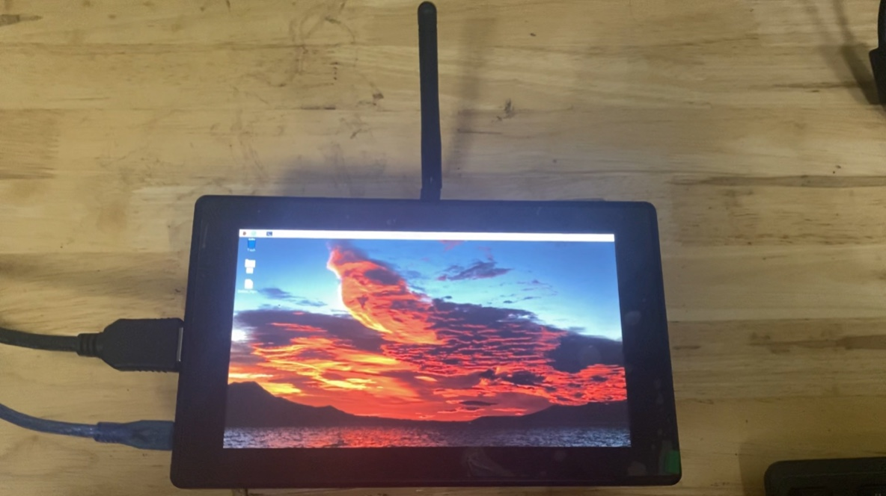

Figure 11: Station monitor

* Structure:

Table 4: Station Components

|  |  |
| --- | --- |
| Controller | Raspberry Pi 4 Model B - 4 GB RAM |
| Network | * Lora * HTTP requests |
| Monitor | Mini screen |
| Other | * Keyboard * Mouse * Indicator LEDs * Button |

- Station Role within the Central Node Network:

+ Data Reception and Analysis: In its capacity within the Central Node Network, the station acts as a central hub for communication with the various sensor and motor nodes. It receives environmental data from the sensor nodes, which includes measurements like temperature, humidity, and soil moisture. The station performs real-time data analysis, ensuring that the data collected from the nodes is processed efficiently.

+ Control Commands to Motor Nodes: Based on the analysis of the data and predefined thresholds, the station sends control commands to the motor nodes. For instance, if the analysis indicates a need for irrigation, the station sends instructions to the relevant motor node to activate the irrigation system. It acts as a command center, ensuring that actions are taken to maintain optimal agricultural conditions.

- Gateway Role within the Internet Network:

+ Data Filtering and Cloud Integration: When serving as a gateway in the wider Internet network, the station filters and processes data received from the nodes. It then facilitates the transfer of this data to the cloud-based database. This integration with the cloud allows for secure, remote storage of historical and real-time data, enabling users to access their agricultural information from anywhere.

+ User Command Reception: The station is also responsible for receiving user commands and options from the mobile app. Users can adjust settings, initiate manual controls, and configure alerts and schedules through the app. The station processes these user inputs and communicates them to the respective nodes, facilitating user control over their agricultural operations.

- Features:

+ Ability to connect additional nodes to the Raspberry Pi.

+ Using rlc byte to confirm data integrity

+ Support for connection mode:

Table 5: Connection mode for specific garden

|  |  |
| --- | --- |
| **Connection Mode** | **Including** |
| Sensor Mode | Sensor only |
| Motor Mode | Motor only |
| Hybrid Mode | Sensor and Motor |

+ Support for control mode:

Table 6: Control mode for specific garden

|  |  |
| --- | --- |
| **Control Mode** | **Brief Describe** |
| Auto  (Available: Hybrid Mode) | -The station takes on the role of analyzing data from the node sensor, then controlling the node motor |
| Manual  (Available: Motor Mode, Hybrid Mode) | - Allows users to directly control the motors |

+ Provide a login interface for users.

### **2.1.3. Server**

The server in agricultural system functions as a central, coordinating various critical tasks:

- Data Reception and Storage: The server continually receives incoming environmental data from the central processing station, which is collected by sensor nodes deployed across the agricultural landscape. This stream of data is meticulously recorded and stored in a secure database, ensuring accessibility and maintaining historical records for future reference.

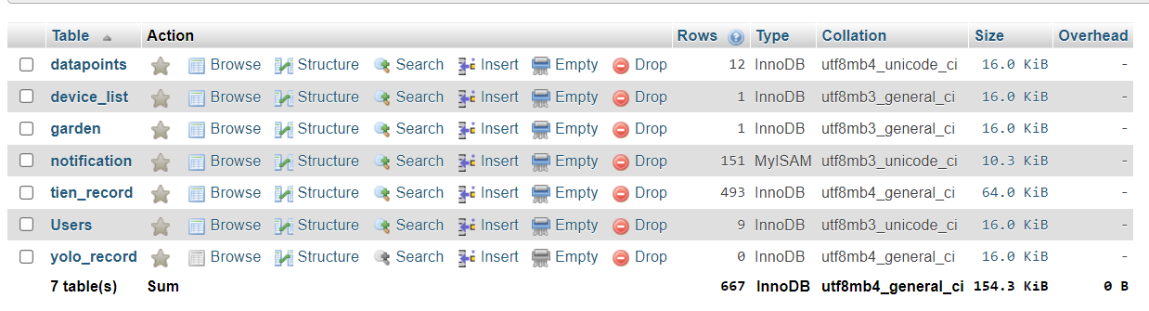

Figure 12: Tables of database

- Data Processing and Analysis: Equipped with advanced analytical algorithms, the server diligently processes the incoming data. It scrutinizes key factors like temperature, humidity, and soil moisture to detect adverse conditions that may impact crop health. Predefined thresholds trigger specific actions and alerts for timely and proactive farm management.

- User Notifications: Using service ‘notificaiton messaging’ from Firebase, the server operates as a vigilant sentinel. It promptly disseminates real-time alerts and notifications to users when unfavorable conditions are detected.

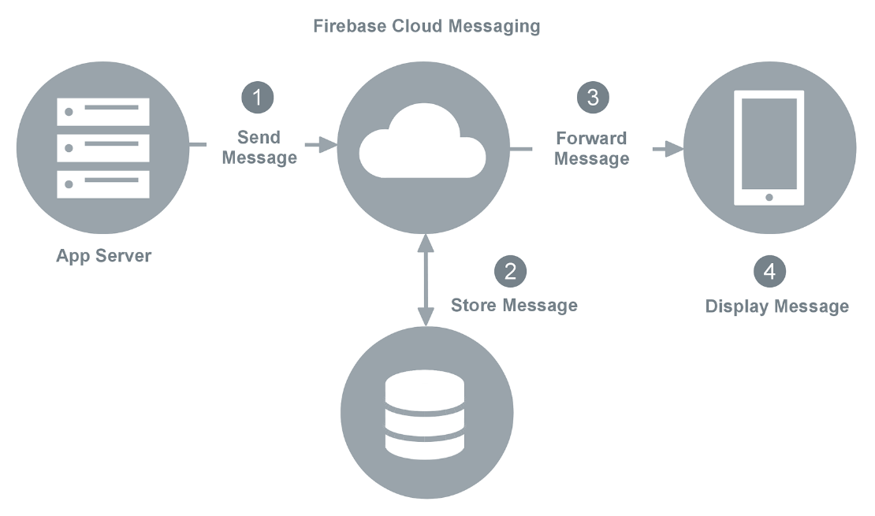

Figure 13: Firebase Cloud Messaging

- Data Logging and Reporting: The server doesn't stop at real-time alerts. It also maintains a comprehensive log of historical data, enabling users to review trends and past conditions.

- Data Security and User Information Protection: The server prioritizes data integrity and user information security. It securely stores and hash user data (using hasing technology), including account details and preferences, to prevent unauthorized access.

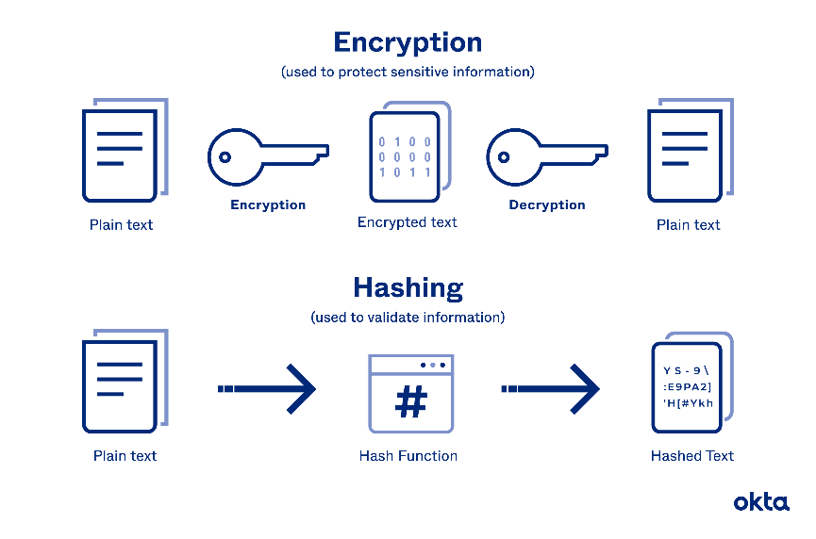

Figure 14: How hashing algorithms works

- Features:

**+** Communication protocol: HTTPS request methods

+ Method: POST, GET

+ Additional sevices: Firebase (Messaging)

+ User information protection: Hashing algorithms

### **2.1.4. Application**

The Mobile App in your agricultural system serves as a versatile tool for users, offering a range of essential functions:

- User Account Management:

+ Account Creation: Users can create their accounts through the app by providing necessary information.

+ Login: Existing users can log in securely to access their accounts.

- Garden Management:

+ Create Gardens: Users have the capability to create multiple gardens within the app, representing different areas of their agricultural landscape.

+ Assign Nodes: Users can associate specific sensor and motor nodes with each garden, allowing for customized monitoring and control.

+ Node Configuration: The app enables users to edit and configure node devices. This is particularly useful when replacing a malfunctioning node with a new one, ensuring uninterrupted functionality.

- Data Visualization:

+ Dashboard: Users can view real-time environmental data, including temperature, humidity, and soil moisture, obtained from the server. The app's dashboard provides an intuitive graphical representation of this data for quick insights into the conditions of their gardens.

- Manual Mode: In instances where manual intervention is required, users can take control. They can manually activate or deactivate motor nodes, making adjustments as needed for irrigation, heating, or other operations in their gardens.

- Alerts and Settings:

+ Alert Configuration: Users have the flexibility to customize alert thresholds and parameters, such as setting humidity or temperature limits for their gardens. This ensures they receive notifications tailored to their specific requirements.

Table 7: Range of warning setting

|  |  |
| --- | --- |
| **Warning** | **Range** |
| Air humidity warning | 0% – 100% |
| Soil Moisture warning | 0% - 100% |
| Temperature warning | 0°C – 50°C |
| Battery warning | 0% - 100% |

+ Irrigation Schedule: Users can modify irrigation schedules, including the timing and duration of watering cycles, based on changing needs.

## **2.2. Algorithms**

### **2.2.1 Nodes**

#### **a. Node sensor**

|  |  |
| --- | --- |
| **Main:**  **Initialize: eusart, letimer, iadc**  **Enter EM2** | **Button interrupt:**  **Button_0: Button_1:**  **Start/Stop working**  **Transmit the connection data to station.**  **- Enable the eusart interupt.**  **- Enable the letimer interrupt.** |

Figure 15: Node sensor algorithms

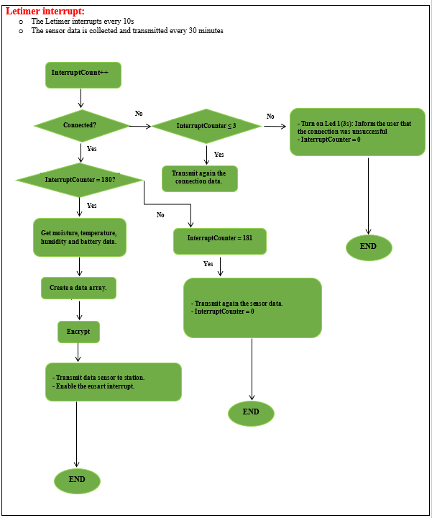

Figure 16: Letimer interrupt

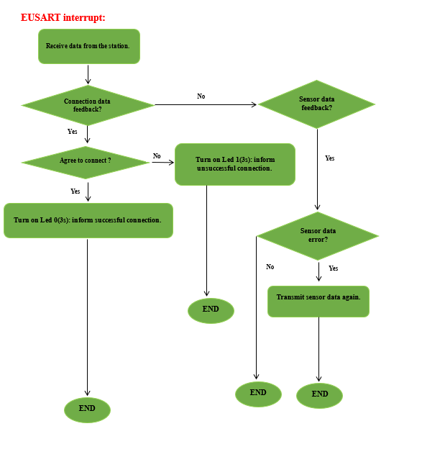

Figure 17: EUSART interrupt

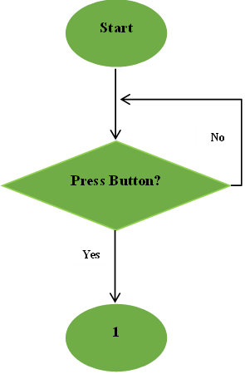**b. *Node motors***

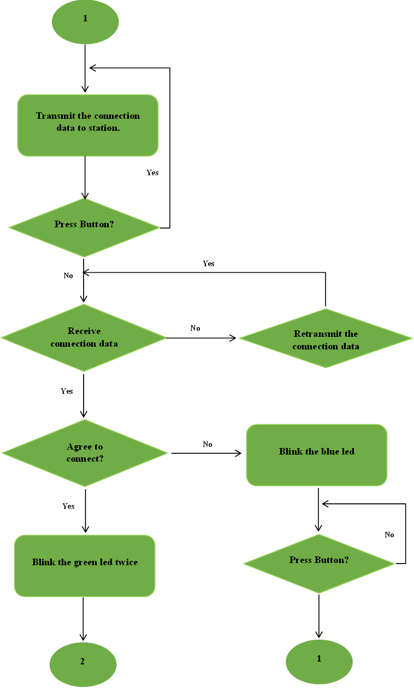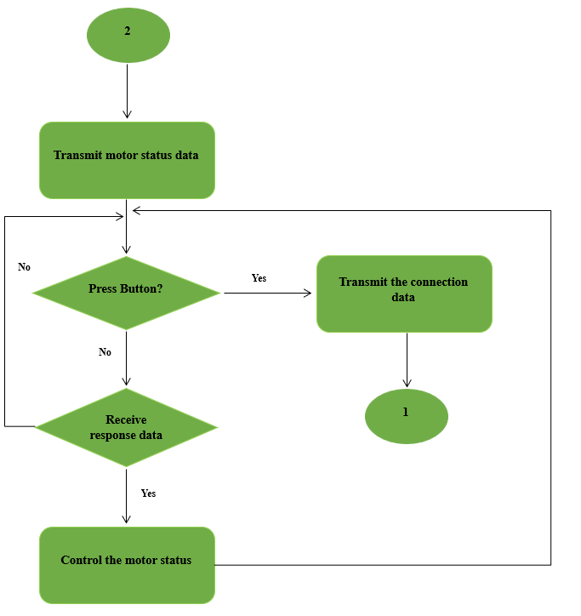

Figure 18: Main node motor algorithms

### **2.2.2 Station**

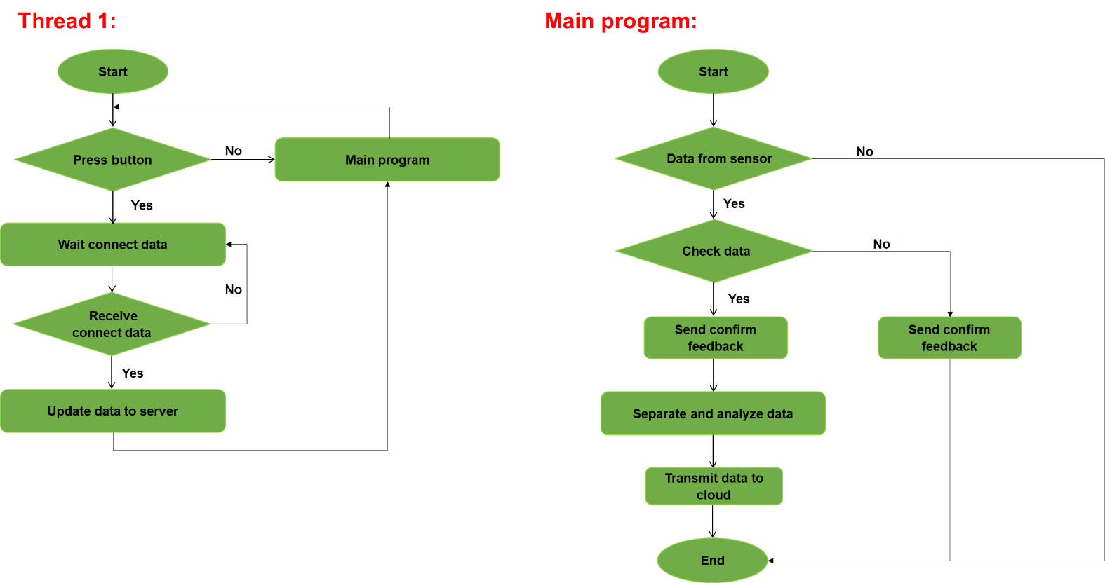

Figure 19: Thread 1 algorithms

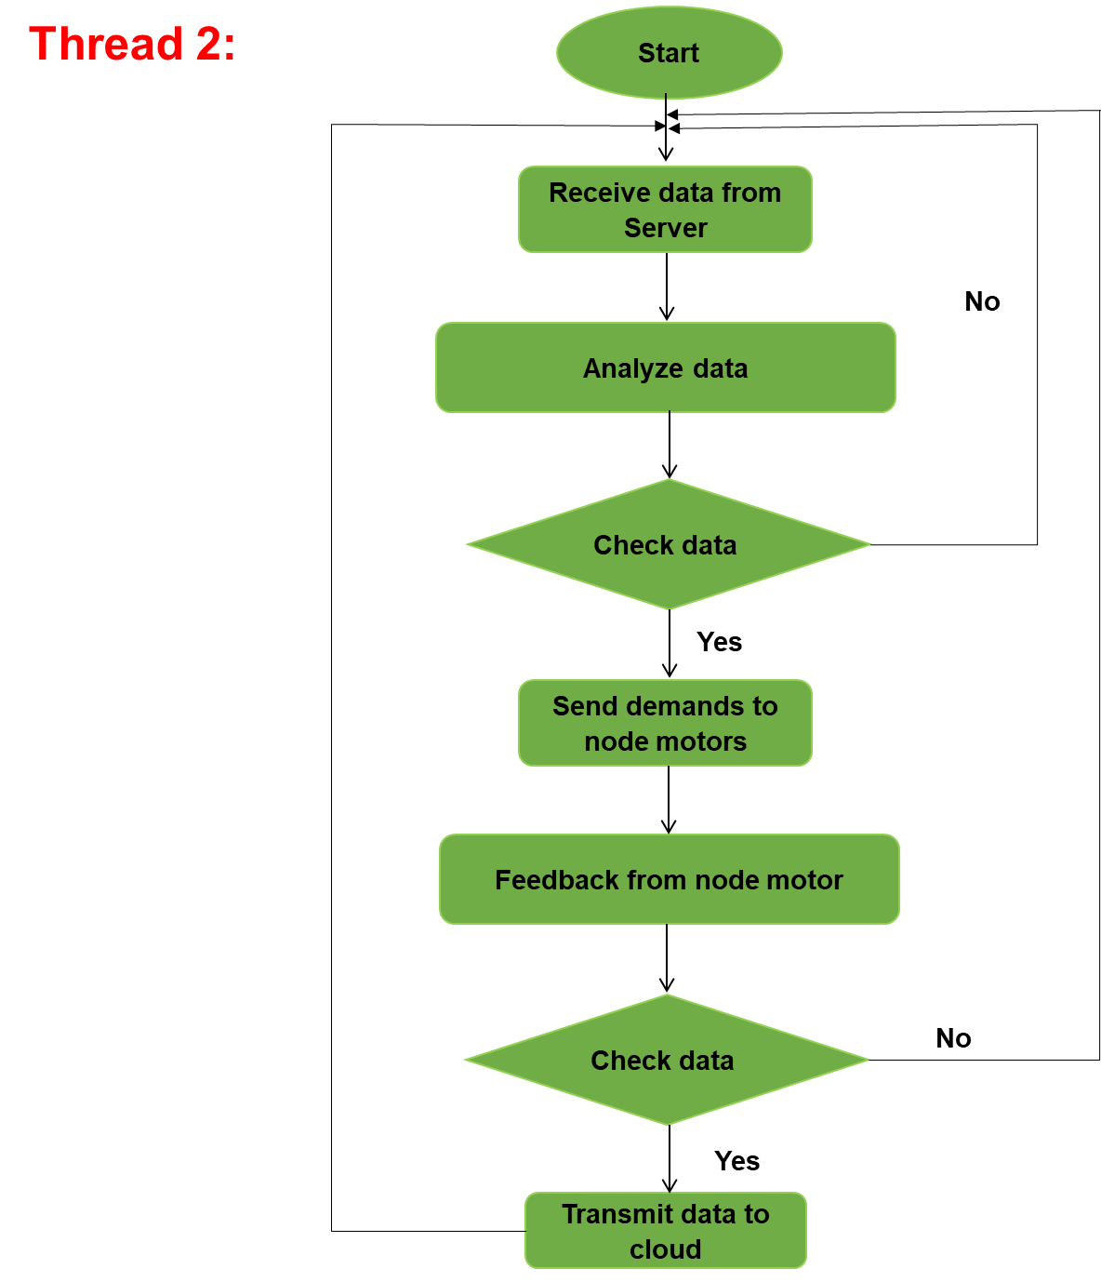

Figure 20: Thread 2 algorithms

# **CHAPTER 3: HARDWARE AND SOFTWARE DESIGN**

## **3.1. Hardware Design**

### **3.1.1 Supply circuit**

The supply circuit is a critical component of our system, responsible for efficiently and reliably providing power to various elements within our setup. It is designed to accommodate the diverse voltage and current requirements of both our sensors and motors, ensuring smooth and consistent operation.

*Power Supply for Sensors:*

Our sensors require a stable 5V power source to operate effectively. To meet this requirement, we have implemented a power solution using three 18650 lithium-ion cells, each providing 3.7V and 1500mAh capacity. These cells are connected in series to create a 11.1V supply. To reduce this voltage to the desired 5V level for the sensor node, we have integrated a buck converter into the circuit. The buck converter efficiently lowers the voltage while ensuring a constant 5V output, meeting the power needs of our sensors and ensuring their accurate and dependable performance.

*Power Supply for Motors:*

For the motors in our system, we exclusively rely on a 5V-2A adapter to provide power to both the motors and the motor control node. The adapter offers the necessary voltage and current output to cater to the motor's requirements. The motor control, responsible for toggling the motors on and off, is achieved using a relay that is controlled by the motor control node.

### **3.1.2. Isolation circuit**

Our isolation circuit is an essential component of our system, designed to enhance safety and protect sensitive components from potential risks posed by the power source. It employs Opto-isolators to create a robust barrier between the power supply circuit and various nodes, effectively mitigating several potential hazards that could compromise the overall performance and integrity of our system.

### **3.1.3. Sensors**

- Soil moisture sensor : *Capacitive Soil Moisture Sensor SEN0193*

* made of corrosion resistant material and gives real-time soil

moisture data

* Output Voltage: 0 ~ 3.0VDC
* Operating Current: 5mA
* Interface: PH2.0-3P
* Dimensions: 3.86 x 0.905 inches (L x W)
* Weight: 15g

- Air humidity sensor & Temperature sensor:

Figure 21: Soil moisture sensor

* Small size & low consumption & long transmission distance(20m)

enable DHT22 to be suited in all kinds of harsh application occasions

* 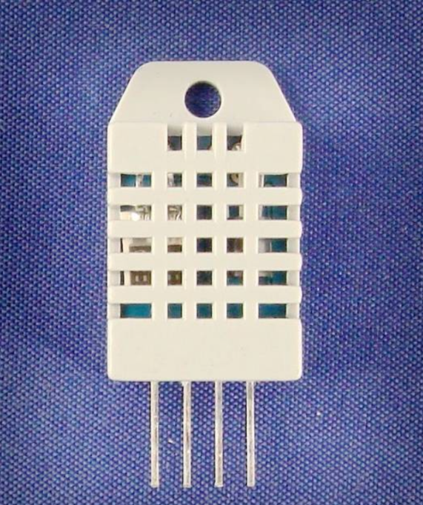Power supply: 3.3-6V DC
* Output signal: digital signal via single bus
* Sensing element: Polymer capacitor
* Operating range: Humidity: 0-100%RH

Temperature: -40~80Celsius

* Accuracy: Humidity: +-2%RH(Max +-5%RH)

Temperature: <+-0.5Celsius

* Resolution or sensitivity: Humidity: 0.1%RH

Temperature: 0.1Celsius

* Repeatability: Humidity: +-1%RH

Temperature: +-0.2Celsius

* Humidity hysteresis: +-0.3%RH
* Long-term Stability: +-0.5%RH/year
* Sensing period: Average: 2s
* Interchangeability: fully interchangeable
* Dimensionssmall: Size: 14*18*5.5mm

Figure 22: Air humidity sensor & Temperature sensor

Big Size: 22*28*5m

### **3.1.4. Pumps**

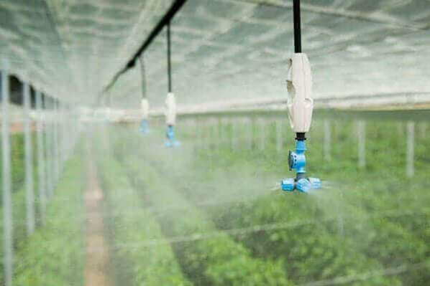- Watering motor & Mist engine: *MB370 DC3.7-6V*

Figure 23: Irrigation Header

* Voltage: 3 - 6V DC
* Current: 0.3A
* Dimensions: 60x26mm
* Water Inlet Head: 5mm
* Water Push Out Head: 5mm
* 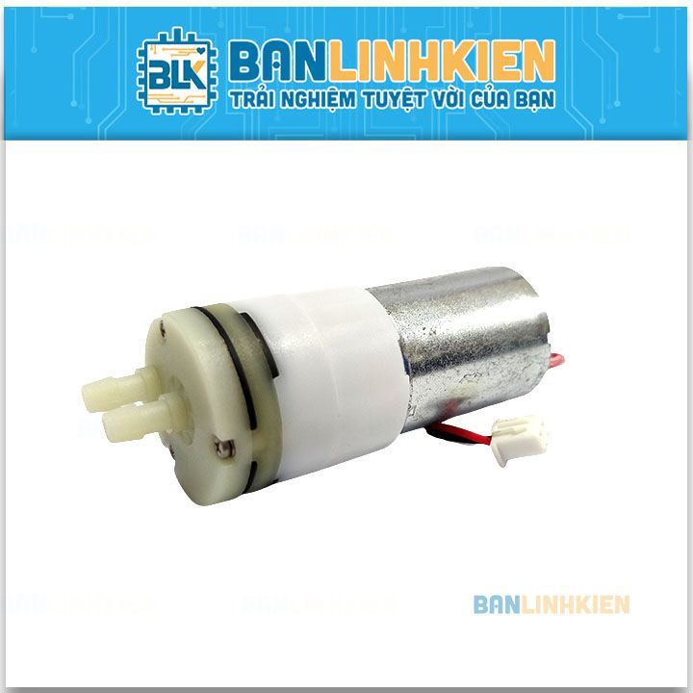Water temperature: 0-60 degrees Celsius

Figure 24: Water Pump

### **3.1.5. Fan**

* 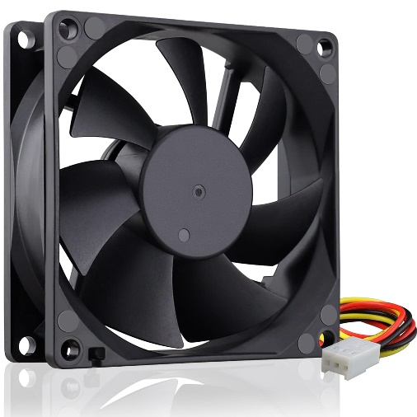Fans are used to lower the temperature in the garden when it exceeds permissible levels, as well as to regulate the overall temperature throughout the garden.

Figure 25: Fan

* Specifications:
* Connect: USB
* Rated voltage: 5V
* Rated current: 0.2A
* Speed: 2500RPM ± 10%
* Airflow: 22CFM ± 10%
* Bearing type: plain bearing
* Noise level: 25dBA ± 10%
* Cable length: approx. 30cm

### **3.1.6 LoRa**

* *Module RF SX1278 Lora E32*

The system employs LoRa (Long Range) technology for the transmission and reception of data between the central station and various nodes. Each node is equipped with a dedicated LoRa module, each assigned a specific address to facilitate seamless operation. Below are the key parameters of the LoRa modules:

* Manufacturer: EBYTE
* 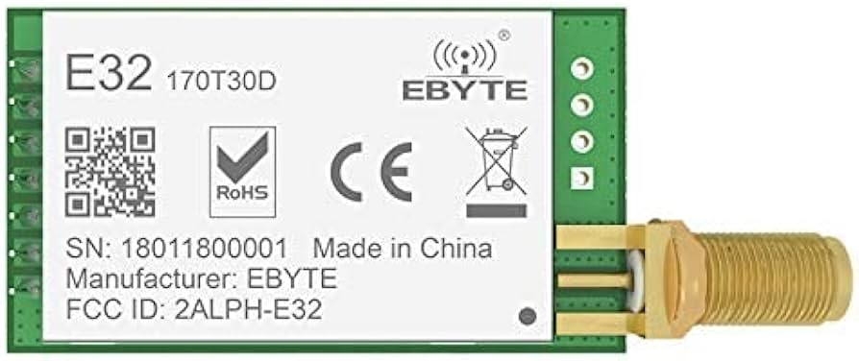Main IC: SX1278 by SEMTECH.
* Operating Voltage: 2.3 – 5.5 VDC
* Transmission Speed: 0.3 – 19.2 Kbps (default 2.4 Kbps)
* UART Interface: Data bits 8, Stop bits 1, Parity none, Baud rate from 1200 – 115200 Bd
* Frequency Range: 410 – 441MHz
* Buffer Memory: 512 bytes
* Supports 65536 configuration addresses

Figure 26: Module RF SX1278 Lora E32

### **3.1.7 KiT EK2703A**

TARGET DEVICE

• EFR32MG24 Wireless Gecko System-on-Chip (EFR32MG24B210F1536IM48)

• High-performance 2.4 GHz radio

• 32-bit ARM® Cortex®-M33 with 78 MHz

maximum operating frequency

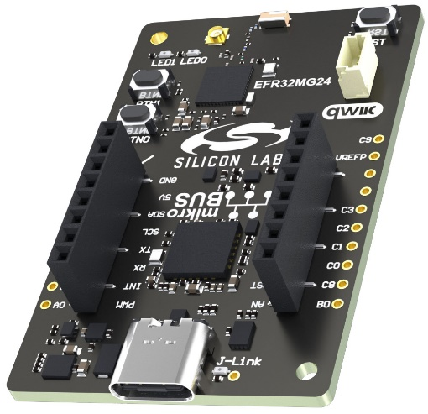• 1536 kB flash and 256 kB RAM

KIT FEATURES

• User LEDs and push buttons

• 20-pin 2.54 mm breakout pads

• mikroBUS™ socket

• Qwiic® connector

• SEGGER J-Link on-board debugger

• Virtual COM port

• Packet Trace Interface (PTI)

• USB-powered

## **3.2. Software Design**

### **3.2.1 Start interface (on Station)**

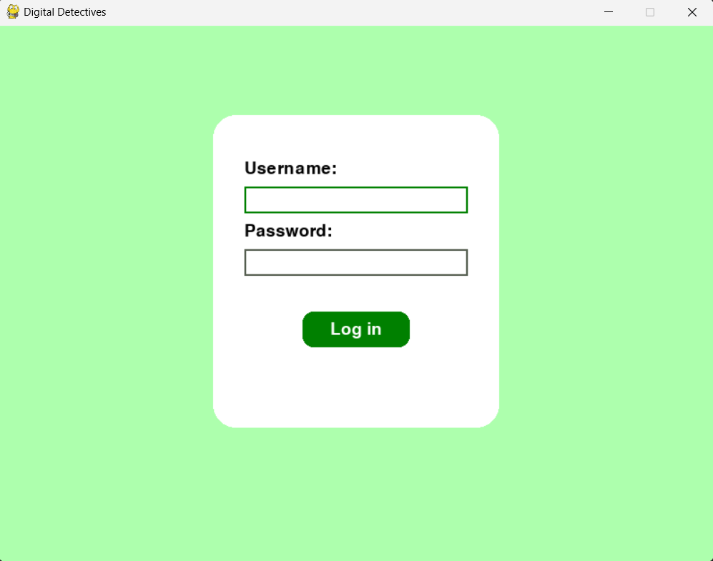

Figure 27: Log in intergace on station

### **3.2.2 App (on Mobile)**



Figure 28: Log in interface

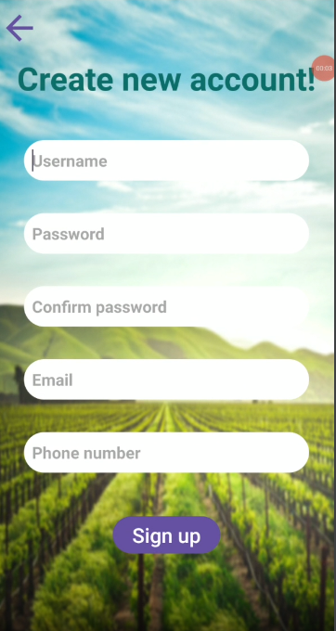

Figure 29: Sign in interface

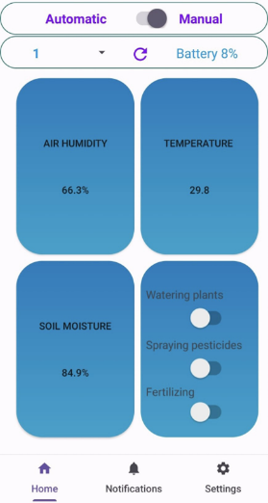

Figure 30: Dashboard

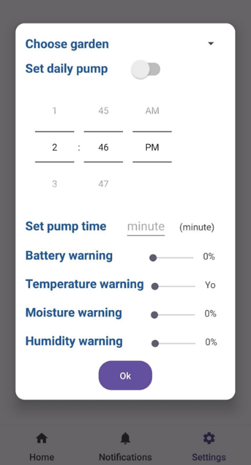

Figure 31: Setting interface

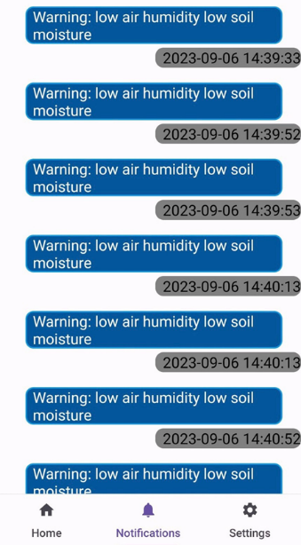

Figure 32: Notifications interface

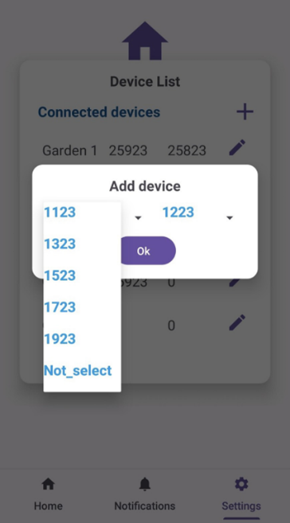

Figure 33: Pairing device on App

# **CHAPTER 4: RESULTS AND PRODUCT EVALUATION**

## **4.1. Design results**

**4.1.1 Station**

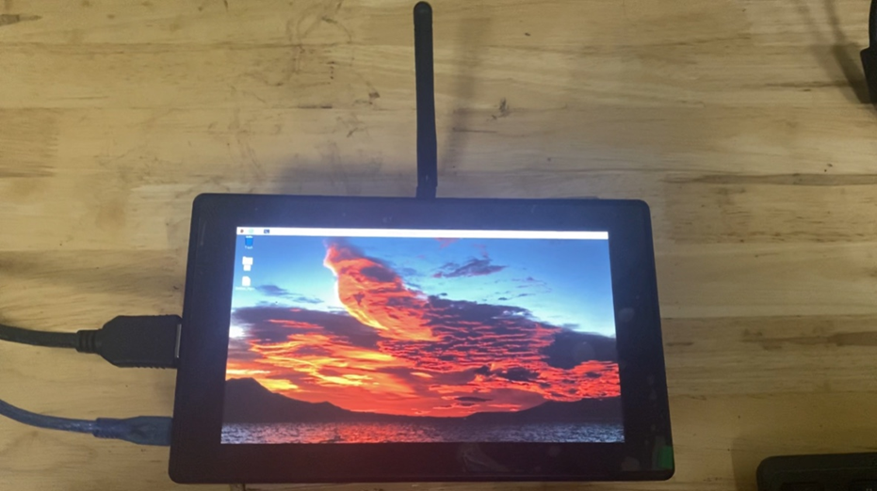

Figure 34: Station

**4.1.2 Node Sensors**

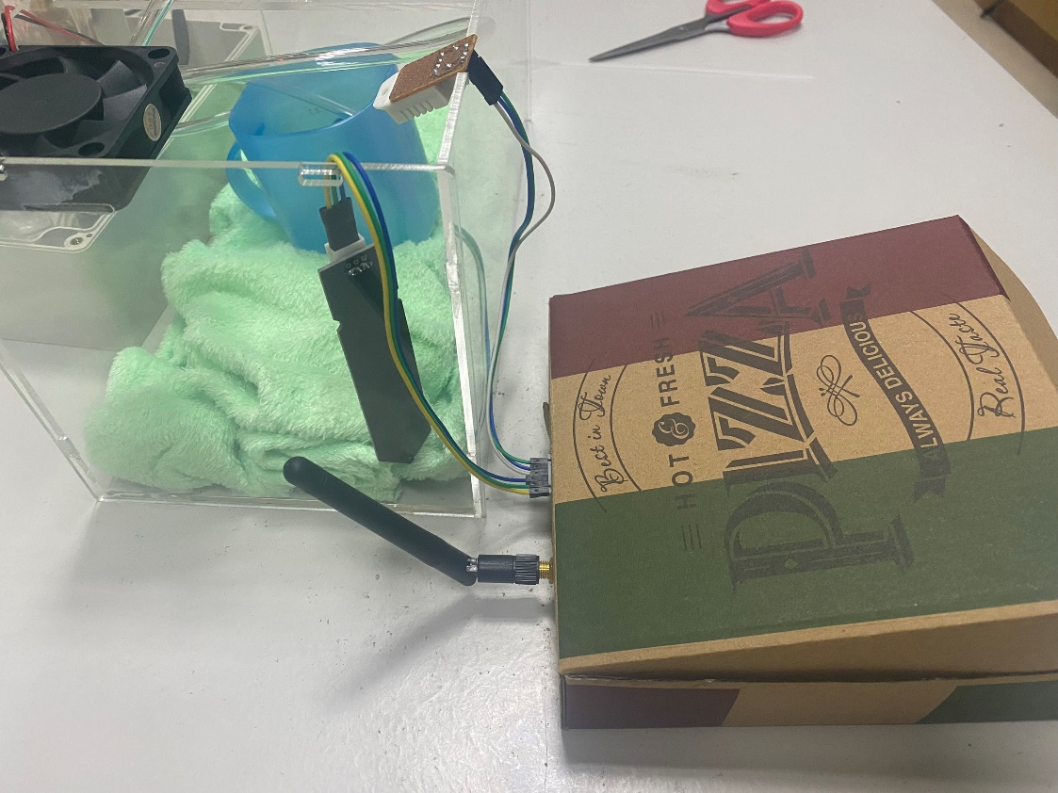

Figure 35: Node sensors

**4.1.3 Node Motor**



Figure 36: Node motors

## **4.2. Test Results**

* The system has fully operated according to the set goals and functions

## **4.3. Future Development Directions**

* Build a new operating system running system software
* Device addresses can be changed manually
* HMI integration
* Intergrate more sensors
* Improve system efficiency
* Using solar power source

# **CONCLUSION**

In conclusion, our agricultural system has not only met but exceeded its initial objectives, bringing a paradigm shift to modern farming practices. The harmonious integration of sensor nodes, motor nodes, a central processing station, a cloud-based database, and an intuitive mobile app has ushered in a new era of agricultural management that combines precision, efficiency, and user-friendliness.

This system has proven its mettle in various crucial domains. Firstly, it excels in resource optimization, harnessing real-time data from sensor nodes to fine-tune resource allocation. Whether it's managing soil moisture, monitoring temperature, or controlling humidity, the system ensures that every action is meticulously calibrated to suit the specific needs of each crop. The result? Improved crop health, increased yields, and resource savings.

Furthermore, our mobile app empowers users to take charge of their agricultural endeavors with ease. The intuitive interface enables them to create and manage gardens, control devices, set personalized alerts, and access historical data—all from the convenience of their mobile devices. This empowerment fosters proactive farming practices, enhancing resource utilization and productivity.

Data security and privacy are of paramount concern in our system. Robust measures have been implemented to protect sensitive user information, with data encryption and strict compliance with data privacy regulations, ensuring peace of mind for our users.

The system's cloud integration, combined with the central processing station's gateway functionality, has democratized remote accessibility. Users can stay connected to their farms from anywhere in the world, making real-time decisions and adapting to evolving conditions.

While celebrating our current achievements, we remain firmly committed to the path of progress. The future holds promising opportunities for further system development and enhancement. We envisage ongoing efforts to boost system performance, fortify security protocols, and bolster overall reliability. Continuous exploration of new features and capabilities will further streamline agricultural management and elevate sustainability in farming practices.

In essence, our agricultural system is a testament to innovation in modern agriculture. Its successful implementation establishes a robust foundation for future advancements. As we look ahead, we are dedicated to contributing to a more productive, efficient, and sustainable agricultural landscape, benefitting farmers and global food security alike.